Clara Eberhard

VBA Homework #2

Screenshots of Worksheets

2016 Worksheet:

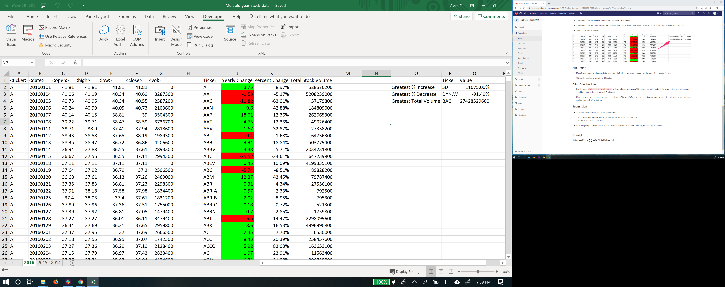

2015 Worksheet:

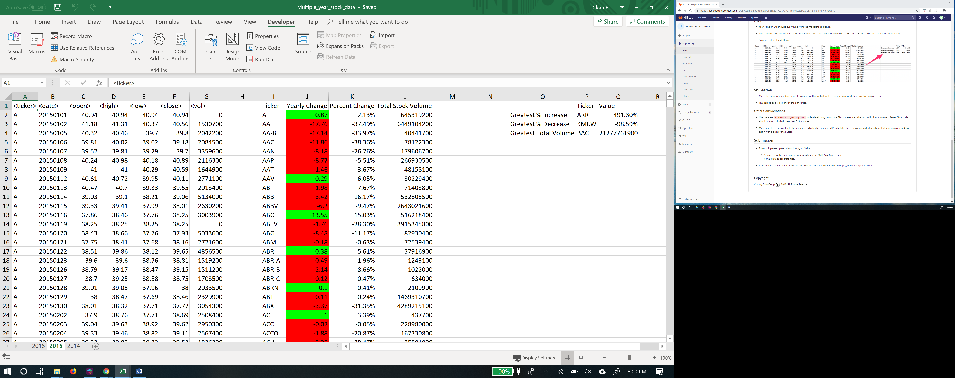

2014 Worksheet:

